November is NLDAC’s Anniversary Month
This November, help us celebrate the work NLDAC is doing and ask your followers to #TravelEasy! We have developed tools and resources for you to share using
social media, newsletters and company intranets on NLDAC’s anniversary, November 8,
and beyond. Here are some things you can do:
• Thunderclap
Sign up your organization to support NLDAC’s campaign
on NLDAC’s anniversary, November 8, with a tweet or a Facebook post.
• Social Media Toolkit
Please help us spread the word on social media using sample Twitter, Facebook, and
Instagram posts.
Who should I contact if I have questions?
If you have questions about Travel Easy or any of the resources attached in this email,
please contact me at nldac@livingdonorassistance.org
Travel Easy Toolbox
NLDAC aims to reduce financial disincentives to living organ donation. So, this November 8th, the day we received our first application over a decade ago, we’re asking you to #TravelEasy with NLDAC! Make NLDAC part of everyday conversation with your patients.
+ Sample Tweets
- Who is eligible for living NLDAC? Find out. LivingDonorAssistance.org #TravelEasy [TWEET THIS]
- How to Apply for NLDAC? Find out more. LivingDonorAssistance.org #TravelEasy [TWEET THIS]
- What happens after I am approved? Find out here. LivingDonorAssistance.org #TravelEasy [TWEET THIS]
- NLDAC is reducing financial disincentives, one living donor at a time. Find out how. LivingDonorAssistance.org #TravelEasy [TWEET THIS]
- Today, November 8, is NLDAC's anniversary. Let’s make #TravelEasy for eligible living donors. LivingDonorAssistance.org [TWEET THIS]
- Living donors are the real MVPs! Let’s give them all the love by making #TravelEasy [TWEET THIS]
- Living donors are all-star champions! Let’s make #TravelEasy for them. [TWEET THIS]
- Headed to #ASTSWinter? Stop by @NLDAC’s #TravelEasy booth to see how you can help your patients. [TWEET THIS]
- Living donors are selfless individuals. NLDAC helps them #TravelEasy to be a rainbow in someone else's cloud. LivingDonorAssistance.org [TWEET THIS]
- Headed to #ANNASymp18? Stop by @NLDAC’s #TravelEasy booth to see how you can help your patients. [TWEET THIS]
- NLDAC will always be somewhere over the rainbow to make #TravelEasy for eligible living donors. Learn more. LivingDonorAssistance.org [TWEET THIS]
- Headed to NKF #SCM18? Stop by @NLDAC’s #TravelEasy booth to see how you can help your patients. [TWEET THIS]
- Headed to #TMF? Stop by @NLDAC’s #TravelEasy booth to see how you can help your patients. [TWEET THIS]
- Headed to #LivingDonationAFDT? Stop by @NLDAC’s #TravelEasy booth to see how you can help your patients. [TWEET THIS]
- Headed to #MARCESRD? Stop by @NLDAC’s #TravelEasy booth to see how you can help your patients. [TWEET THIS]
- Headed to #TFCA Stop by @NLDAC_ASTS’s #TravelEasy booth to see how you can help your patients. [TWEET THIS]
- Headed to #STSW Stop by @NLDAC’s #TravelEasy booth to see how you can help your patients. [TWEET THIS]
+Sample Facebook Posts
- Can living donors travel easy to/from transplant centers nationwide? Learn how NLDAC is reducing financial disincentives to organ donation, one eligible living donor at a time.
- Headed to #ASTSWinter? Stop by NLDAC’s #TravelEasy booth to see how you can help your patients.
- Headed to #ANNASymp18? Stop by NLDAC’s #TravelEasy booth to see how you can help your patients.
- NLDAC will always be somewhere over the rainbow to make #TravelEasy for eligible living donors. Learn more. LivingDonorAssistance.org
- Headed to NKF #SCM18? Stop by NLDAC’s #TravelEasy booth to see how you can help your patients.
- Headed to #TMF? Stop by NLDAC’s #TravelEasy booth to see how you can help your patients.
- Headed to #LivingDonationAFDT? Stop by NLDAC’s #TravelEasy booth to see how you can help your patients.
- Headed to #MARCESRD? Stop by NLDAC’s #TravelEasy booth to see how you can help your patients.
- Headed to #TFCA Stop by NLDAC_ASTS’s #TravelEasy booth to see how you can help your patients.
- Headed to #STSW Stop by NLDAC’s #TravelEasy booth to see how you can help your patients.
- Today, November 8, is NLDAC's anniversary. Let’s make #TravelEasy for eligible living donors. LivingDonorAssistance.org

Facebook Profile Frame
Go to https://twibbon.com/support/traveleasy to find our frame. Apply to your profile photo.
Social Media Profile Image
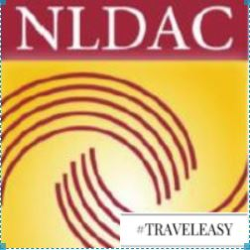

Travel Easy Videos
Am I Eligible for NLDAC?
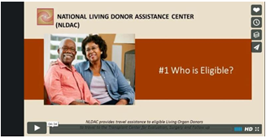
How to Apply for NLDAC?
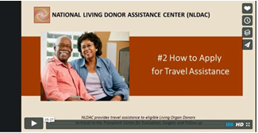
After NLDAC Application is approved
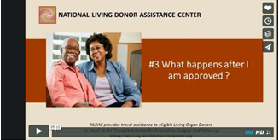
Soy Eligible
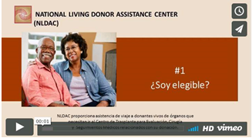
Como Solicitar Ayuda Financiera
