Contact: Maureen Ndoto  National Living Donor Assistance Center  Phone 703-414-1600  Fax 703-414-7874  nldac@livingdonorassistance.org | National Living Donor Assistance Center

Press Release
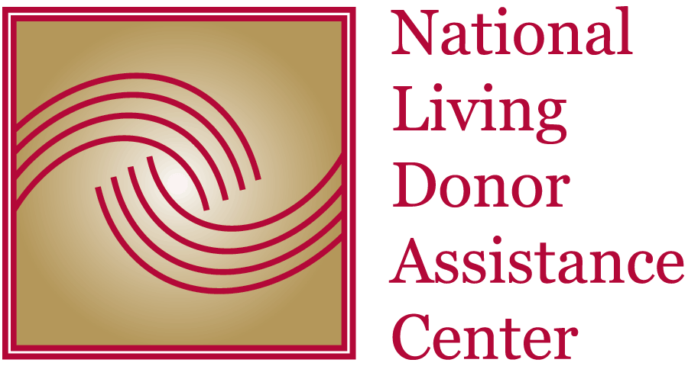

Transplantation: Funding Renewed for Nationwide Program to
Reduce Financial Disincentives for Living Organ Donors

Program Increases Access to Transplantation for Low Income Patients on Waiting List
Arlington, VA, October 15, 2014: The University of Michigan (UM), in partnership with the American Society of Transplant Surgeons (ASTS) and Arbor Research Collaborative for Health (Arbor Research), are pleased to announce they have been selected to continue operating the National Living Donor Assistance Center (NLDAC). Funding for this program was renewed by the Healthcare Systems Bureau, Health Resources and Services Administration, U.S. Department of Health and Human Services, which will provide up to $3.5 million yearly for up to five years.
Launched in 2007, NLDAC provides reimbursement of travel and subsistence expenses for living organ donors to travel to the transplant center to donate an organ. Approved applicants receive a controlled value card, which is like a credit card, to pay for approved transportation, food and lodging expenses up to $6,000.
The program is aimed at helping low income individuals on the wait list, and in accordance with the program authority, the NLDAC cannot provide reimbursement to donors if other possible payers, such as state compensation programs, health insurance companies or the recipient of the organ, can provide reimbursement. Donor and recipient household incomes are means tested at 300% of the federal poverty guidelines. Priority is given to individuals who cannot otherwise afford the expenses. The program provides an exception to this funding threshold for documented financial hardships.
“We are extremely happy that we can continue to provide assistance for living organ donors who provide the gift of life to others,” said Program Director Akinlolu Ojo, MD, PhD, Professor of Medicine at the University of Michigan. “Donors who receive support from NLDAC tell us the program was essential and they would have been unable to be a living donor without the assistance.” Program Manager Kimberly Gifford, MBA, ASTS Executive Director, noted, “To date, NLDAC has processed nearly 5000 applications from 200 transplant centers across the country. We are grateful for the efforts of the transplant center filers who make the program possible and have facilitated over 2400 transplants through NLDAC.”
Living donors usually travel at least three times to the transplant center and are required to stay near the hospital for up to two weeks after the transplant surgery for monitoring. For donors who travel a long distance, these travel costs are prohibitive despite their willingness to donate an organ.
In 2013, NLDAC received 960 applications from 143 different transplant centers and paid $1.8 million in donor travel expenses. On average, approved applicants spent $2,767 for their travel expenses to the transplant center. “ASTS is thrilled to be part of the team that will continue to administer this important program that provides much needed assistance to living donors who are willing to give the gift of life to others. We are honored to facilitate the donation process for these true heroes,” said ASTS President Peter Stock, MD, PhD.
Arbor Research will join ASTS and UM to enhance the applicant experience and identify areas for enhanced program efficiency. “We look forward to making improvements to this already successful program. Website functionality will be augmented to allow for a more streamlined application and review process,” said Arbor Research President and NLDAC Program Deputy Director Robert Merion, MD.
Section 3 of the Organ Donation and Recovery Improvement Act (ODRIA), 42 U.S.C. 274f, establishes the authority and legislative parameter to provide reimbursement for travel and subsistence expenses incurred toward living organ donation. Reimbursements of these expenses are based on the availability of funds and are not guaranteed.
For more information, please visit the National Living Donor Assistance Center website at www.livingdonorassistance.org.

#####

