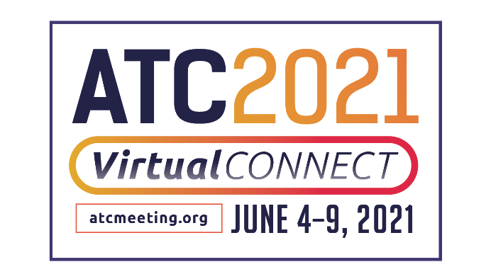

THE AMERICAN TRANSPLANT CONGRESS (ATC) 2021 VIRTUAL CONNECT
TO SHOWCASE CUTTING-EDGE RESEARCH FROM WORLD’S LEADING EXPERTS IN TRANSPLANTATION

ATC 2021 Virtual Connect, the new, enhanced virtual meeting experience for transplantation professionals taking place June 4-9, 2021, will feature a robust program comprised of new scientific and clinical information, discussions around care and management, and socioeconomic, ethical, and regulatory issues relevant to organ and tissue transplantation. This year’s program will also feature new COVID-19 content pertinent to the field of transplantation.
The annual event is the 20th joint meeting of the American Society of Transplant Surgeons (ASTS) and the American Society of Transplantation (AST), both non-profit medical associations for professionals involved in scientific research and advocacy related to the advancement of transplantation.
This year’s program will incorporate even more content than last year's virtual event, with six days of live, broadcasted sessions, including 124 symposia with pre-recorded presentations and live video question and answer, 30 Expert VIP Meet-Up sessions providing access to experts in the field, and live video conversation to take place in small groups. This year will also feature two State-of-the-Art lectures from pioneers in the transplant field. Jeffrey Gordon, MD, will present Development of Microbiota-directed Complementary Foods for Treating Childhood Undernutrition, and Hannah Valantine, MD, will address Inclusive Excellence in Biomedical Research: Applying Genomics to Unravel Health Disparities in Organ Transplantation.

The format allows real-time interactivity through
- Live Video Discussions
- Invigorating Q&A Discussions Post-Presentation
- Live Presentations by Abstract Presenters
- Engaging, Unconventional Networking Breaks
- Live Symposia Presentations

As part of this year’s new Virtual Connect format, specific time slots are scheduled on the Scientific Program to engage live with abstract presenters through Plenary Abstract Sessions, 46 Rapid Fire Oral Abstract Sessions and 16 Poster Video Chat Sessions with pre-recorded presentations and live video question and answer. Attendees will also be able to engage with poster abstract presenters one-on-one through chat and by scheduling individual video meetings through the networking function of the Virtual Connect platform.

In addition, attendees will be able to access Virtual Connect on-the-go, and at their convenience, to earn education credits or contact hours, hear the latest innovations, build their professional network and interact with presenters via chat areas. Registered participants will also gain yearlong access to all Live Broadcast sessions in an OnDemand format recordings within the Virtual Congress Portal through June 3, 2022. The access includes all Plenary Sessions, Rapid Fire Oral Abstracts, and Poster Presentations. Registered attendees may view these sessions and obtain over 200 CME, ACPE, ANCC, CEPTC credits while in the Virtual Congress Portal.

Of special note this year, the program includes:

IMPACT SESSIONS
Industry innovators will explore how the transplant industry is transforming to pave the way for tomorrow’s advancements. Attendees can expect to leave these sessions armed with cutting-edge information on the future of the industry.

IN-DEPTH SYMPOSIA
For the first year, In-Depth Symposia is included in ATC registration and will be held June 4. Session titles are:
- Kidney: Living Donor Selection Where to Draw the Line
- Liver: Pushing Past the Limits of LDLT in the US: Programmatic Development
- Heart & Lung: Don’t Throw Them in the Bucket!!! Tricks of the Trade to Optimize Every Thoracic Donor Offer
- Basic & Translational: New Approaches to Tackling Alloimmunity
- Pharmacy: Comprehensive Management in Multi-Organ Transplantation: It Takes a Village
- Infectious Disease: Transplant Infectious Diseases
- Other: Artificial Intelligence and Machine Learning in Transplantation: The Promise, The Reality, and The (Scary?) Future
- Other: Racism in Transplantation: Current State and Future Directions
- Professional Development & Advanced Practice Provider: Mastering the Transplant Essentials

EXPERT VIP MEET-UPS*
Live Video Discussion, Question and Answer sessions.
These sessions provide exclusive access to Mentor Experts in the field, and take place in an intimate discussion setting, with no formal slide presentations. The purposeful layout is designed to allow interaction and discussion while creating new connections.
*Session attendance is limited to 50 attendees.

WOMEN'S NETWORKING EVENT
Live Video Discussion, Question and Answer sessions.
This year’s ATC networking event for women in transplantation, will go beyond the curriculum to discuss strategies to achieve personal and professional success. The virtual format is designed with eight key topics. Two speakers have been selected for each key discussion topic to hold a joint conversation type presentation, with no formal slides. Participants will enter the virtual event and be automatically placed into small discussion topic groups. Each topic will have 15 minutes of live video conversation facilitated by women leaders in the field. Topic of discussions will be interactive and allow for audience participation. Speakers & participants will be shown with live video. After 15 minutes, the facilitators will be virtually rotated to another group.

About the American Transplant Congress
The American Transplant Congress is designed for physicians, surgeons, scientists, nurses, organ procurement personnel, pharmacists and other transplant professionals who are interested in the clinical and research aspects of solid organ and tissue transplantation. The meeting will provide the most current information in the field of transplant science. Early registration with discounted pricing for the meeting ends May 5, 2021. More information is available HERE. To learn more, visit www.atcmeeting.org or connect with ATC on Twitter, @ATCMeeting, Facebook, and Instagram and LinkedIn.
About the American Society of Transplant Surgeons
The American Society of Transplant Surgeons (ATS) represents approximately 1,900 professionals dedicated to excellence in transplantation surgery. Our mission is to advance the art and science of transplant surgery through patient care, research, education, and advocacy. To learn more, visit ASTS.org.

About the American Society of Transplantation
The American Society of Transplantation (AST) represents more than 4,000 transplantation professionals
dedicated to advancing the field and improving patient care by promoting research, education, advocacy, and organ donation. The AST’s diverse membership includes physicians, surgeons, scientists, nurses, allied health professionals, and administrators. For more information about the AST, please visit myAST.org.
Media Contact:
Julia Brannan-Rauch
julia@mojjocc.com
201-725-7375

