Hotel
Embassy Suite Chaleston Harbor
100 Ferry Wharf Road | Mt. Pleasant, SC 29464
Your confirmation was previously emailed. If you did not receive it, please contact education@asts.org .
Registration
Pick up your name badge starting at 7:30 AM outside the Harbor Ballroom.
Breakfast
Breakfast is included in your stay and will be served at the hotel restaurant from 7:30 – 10 AM. The Symposium starts at 8:45 AM in the Harbor Ballroom.
Ground Transportation
We've partnered with Lyft to provide transportation from the Charleston Airport to/from the Embassy Suites:

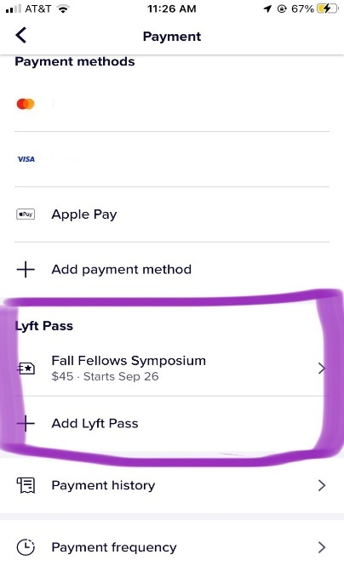
Lyft Directions: BEFORE you request your ride, go to the "Payment" section of the Lyft app and enter the Lyft pass code: 1FALLFS22. Applied credit is displayed on the ride payment screen.
Get the App - Download the Lyft app for iPhone or Android. Already have the Lyft app? Go straight to step 3!

Create Your Account - Set up a Lyft account. You will need to add a credit card in case your Lyft rides go beyond the event. Any additional tips will be charged to your credit card as well.

Submit your info - Add the events code you were given 1FALLFS22 to the "Lyft Pass" section under Payments of the Lyft app BEFORE you request your ride. You must be in "Personal" mode for the code to apply. You will only need to enter this code one time.

From Hotel to Airport: Follow the directions above for your return. Use code: 2FALLFS22

Event App – ASTS Connect
The ASTS mobile app provides you with everything from the schedule to logistical information. Download it now by searching for ASTS Connect in your phone’s app store. Please log in using your login for ASTS.org to connect to your member record and view member-only content.

Dress
Casual attire, including jeans, are appropriate for all session and meal events. Please note, we are planning outdoor afternoon/evening events where temperatures may be 80-90 degrees Fahrenheit so plan accordingly.

Reimbursement
Keep receipts for your airfare and send along with the reimbursement form that will be emailed to you after the meeting.

Pre-Meeting Materials
The Fellowship Training Committee has collected supplemental materials associated with the Symposium’s sessions for fellows to read at their leisure before the meeting. To access the pre-meeting material, click here and login to your ASTS account.

Virtual Bag
Visit the virtual bag for more information.

Guests
If you have not registered your guest and would like them to be able to attend dinners, please contact education@asts.org to ensure your guests can attend the meals.

ASTS gratefully acknowledges support of the Fellows Symposium from the following:
Diamond Level
CareDx
Gold Level
Sanofi
Silver Level
Eurofins Transplant Diagnostics
Medtronic
Veloxis Pharmaceuticals
ASTS gratefully recognizes CSL Behring for providing commercial support / independent medical education grant funding for the Fall 2022 Fellows Symposium.

